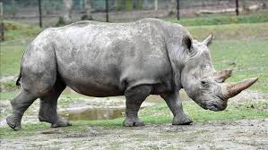

Our next English topic involves non-chronological reports. Your task is to research and write a non-chronological report on the Northern White Rhinoceros.
Background information: Sudan was the last male Northern White Rhinoceros and he died in 2018. There are only two females left, Fatu and Najin. Using your Year 5 Science understanding of animal reproduction, we are sure that you know that two females cannot reproduce in order to re-populate this subspecies of rhinoceros. However, science is ever-evolving, so there may still be hope for this critically endangered animal! Check out the links below and also do your own research:
  - https://www.bbc.co.uk/iplayer/episode/m000c6pn/seven-worlds-one-planet-series-1-7-africa - An excellent watch from the beginning, but from 40minutes in you can see the effect of poaching on Elephants and also the Northern White Rhinoceros.
  - National History Museum - The Future of the White Rhino
  - CNN Article on the White Rhino
When writing your report consider the following:
- Why is the Northern White Rhinoceros nearly extinct?
- What happened to the last male Northern White Rhinoceros?
- Where are the remaining females living? Are they in good health?
- How is this subspecies increasing its population? How is science evolving to create more Northern White Rhinoceroses?
If you would like to write this report in a Word Document, feel free - you can also include a picture or two.

