Be the Change

Children will learn about the life of Rosa Parks. Children will use adjectives to describe how Rosa felt when she was asked to move from her space. Children to discuss the changes to the world that have taken place and how the photographs showing the laws of segregation made them feel.
Children to produce posters detailing the life of Rosa Parks.
The photographs below may be cut up by the children and used for their posters.
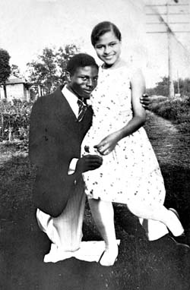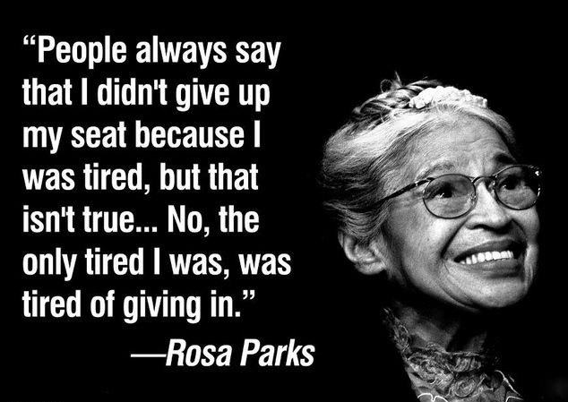
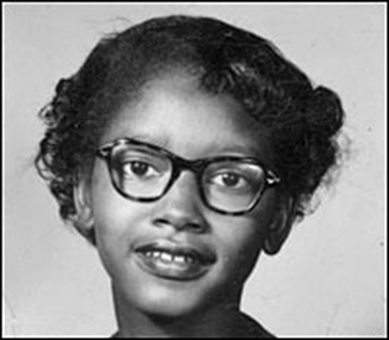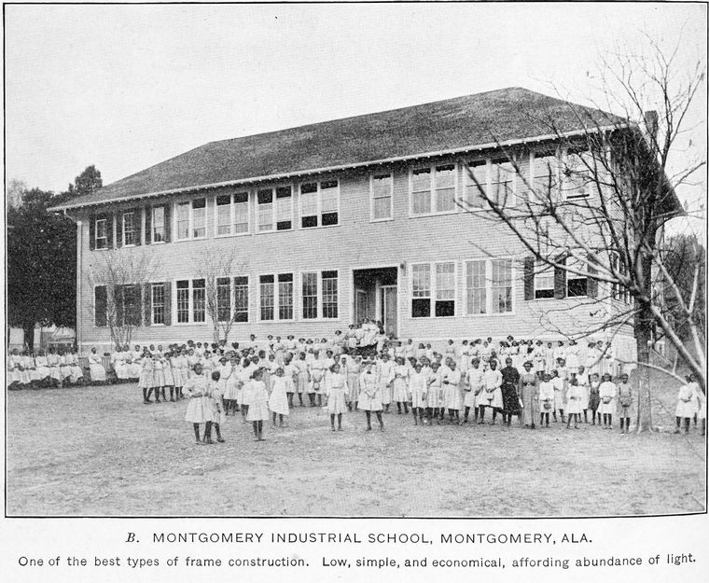
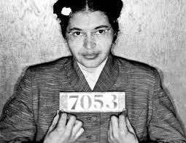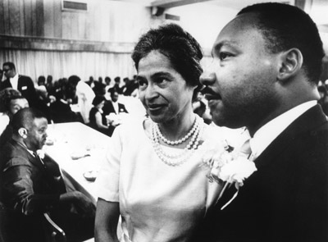

I think Rosa Parks is important because:

Here are the important dates to include in your poster. Use the photographs provided by your teacher to show Rosa Parks’ story. Can you remember what life event happened then?

1913

1924

1932

1955

1968

About Rosa Parks:

I think Rosa Parks is important because:

I think Rosa Parks is important because:

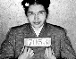
Rosa Parks Word Bank

Rosa Parks African American Bus

Segregation Blacks and whites Refused

Seat America Wrong

Bad choice Brave

