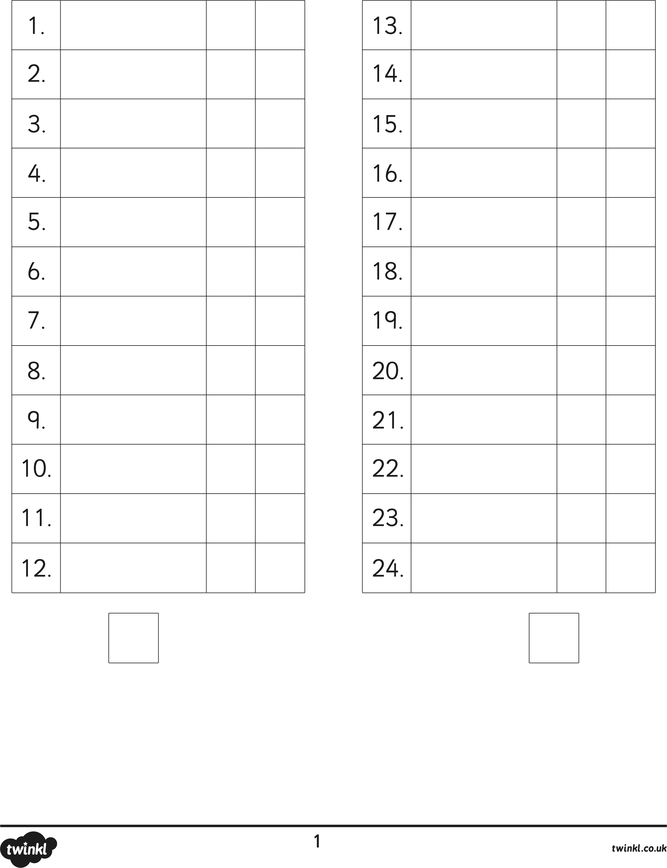
Number Bonds to 20
Check
Check
My Score:
My Score last time:
How can I improve next week:
? + 10 = 20
? + 18 = 20
? + 5 = 20
? + 6 = 20
? + 11 = 20
? + 3 = 20
? + 14 = 20
? + 12 = 20
? + 2 = 20
? + 7 = 20
? + 19 = 20
8 + ? = 20

20 = 11 + ?
6 + ? = 20
17 + ? = 20
? + 3 = 20
13 + ? = 20
19 + ? = 20
20 = ? + 13
20 = ? + 4
20 = 11 + ?
20 = ? + 0
13 + ? = 20
6 + ? = 20

Name:

