Spider’s Rainbow
Objective: Add and subtract multiples of 10 to/ from 2-digit numbers.
You will need: sets of number cards 31 to 70, 1 to 6 dice, colouring pencils
- Choose a 2-digit number card, e.g. 42. Circle this number on the 1-100 grid:

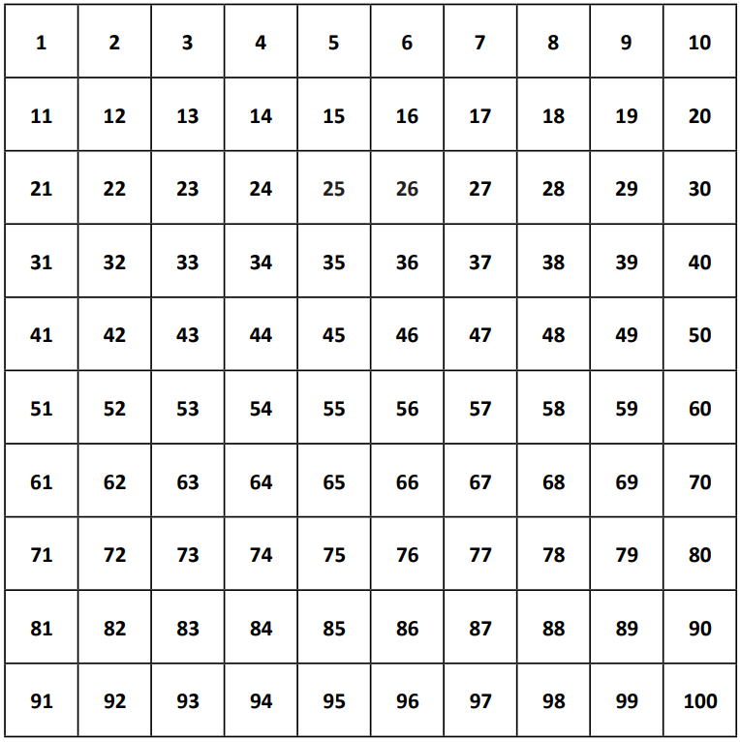
- Roll the dice. Let’s pretend you roll a 2. Add and subtract this number of 10s from your circled number (2 tens are 20).
- Write the number sentences, e.g. 42 + 20 = 62 42 – 20 = 22
- Now for the fun bit! Colour in your answers on the 1-100 grid, using this code:
        - If you rolled a 1, adding and subtracting 10, colour red
        - +/- 20 orange
        - +/- 30 yellow
        - +/- 40 green
        - +/- 50 blue
        - +/- 60 violet (purple)
So we would colour 62 and 22 orange…
- Keep rolling the dice, adding and subtracting until you have coloured all of the possible squares Spider can land on from that starting number.
- Look at the pattern someone else made. Is yours similar/ very different? Why?
- Repeat with a different 2-digit starting number.
- Can you make a whole ‘rainbow’ of our six colours starting on any number 31 to 70?

